Driver Distraction, Secondary Visual Task Load,
and Attention-Related Abilities

K. Hurts¹ and B. Sjardin²
^{1,2}Department of Psychology, Leiden University, The Netherlands
Email: ¹hurts@fsw.leidenuniv.nl; ²bassjardin@gmail.com

ABSTRACT
In this study, the ability of three attention-related psychological tests to predict the amount of driver distraction, caused by a secondary task not related to driving, was investigated. The three tests were as follows: 1) A test for measuring visual divided attention capability (Useful Field of View test, or UFOV); 2) A test for measuring task-switching ability (TSA-IAT), and 3) A self-designed task for measuring a person's ability for (visual) controlled processing, called Complex Visual Search (CVS). Driver distraction was measured using a standardized PC-based tool, called the Lane Change Task (LCT). A visual search task, imposing either a low or a high demand on the driver's visual processing capacity, served as secondary task to be performed simultaneously with the (primary) driving task (LCT). Results of an experiment using 20 subjects showed that, as expected, both secondary tasks were significantly distracting in an overall sense. In addition, UFOV- and TSA-IAT-performance significantly predicted the driver's baseline driving performance (without distracting secondary task) in the expected direction. However, contrary to expectation, high UFOV-performance also significantly predicted a large amount of distraction caused by the complex visual (secondary) task. CVS-performance was only weakly related to any LCT-based performance measure. Potential explanations and applications of these results will be offered.

INTRODUCTION
Attentional problems are estimated to account for 5 - 25 % of all car accidents (Young, Regan, & Hammer, 2003; Pettitt, Burnett, & Stevens, 2005). According to a recent white paper about the future of the field of traffic safety, driver attention and distraction are estimated to be the most important human factors research issues of the coming years with the potential of directly affecting traffic safety (AAA Foundation for Traffic Safety, 2006).
Obviously, when driving, not all types of distraction can be avoided. Therefore, driver psychology becomes important as a means to find out how drivers can be selected or trained to be prudent users of such potentially dangerous technologies.
In this article we investigate the role played in driver distraction by three attention-related abilities. Specifically, we study the extent to which the scores on tests for measuring these abilities can be used to predict the amount of distraction experienced by the same drivers when performing a secondary visual task while driving a car in a driving simulator.

PROBLEM STATEMENT AND HYPOTHESES

Psychological tests
The three tests and the corresponding abilities are as follows:
- Test for Useful Field of View (UFOV) (PC-based version), subtest 3: Useful Field of View is defined as the visual area in which one can extract useful information without eye or head movements (sometimes also called simply Functional Field of View or FFOV). Subtest 3 is the most complex subtest of the UFOV which measures, in addition to divided attention ability, aspects of central processing speed and of selective attention (Ball & Owsley, 1993).
- Test of Task-Switching Ability (TSA), using the paradigm of an Implicit Association Test (IAT): test is assumed to measure a person´s ability to switch between task sets (Back, Schmukle, & Egloff, 2005), an ability often associated with attentional (or executive) control and with general intelligence (Duncan et al., 1996).
- A task for Complex Visual Search (CVS): a self-designed task used to measure the ability of a person to detect a conjunction-type visual target presented in an array of visual distractors. The task is based on Ackerman (1988) and is assumed to require a type of “controlled processing” related to general intelligence.
For some of these abilities (e.g., UFOV) it is known (or likely) that they are age-sensitive (Ball, Roenker, & Bruni, 1990), older drivers having less of these abilities than younger drivers do. Therefore, in this study we will also look in an exploratory sense at age effects in both test scores and amount of driver distraction.
In this study, driver distraction was induced by two secondary tasks. The first secondary task is an easy visual task (imposing a low visual load on the driver). The second secondary task is a complex visual task (imposing a high visual load on the driver), requiring mainly controlled processing.

Hypotheses
Based on the literature, we decided to test the following hypotheses:
1. Performing either secondary task is distracting in an overall sense, but performing an easy visual secondary task is less distracting for the primary driving task than performing a difficult visual secondary task. (Confirmation is required in order to be able to test hypotheses 2, 3, and 4.)
2. The higher the performance on the UFOV, the better the driver is able to combine a visual secondary task with the primary driving task, and, hence, the smaller the amount of driver distraction caused by the secondary task.
3. The higher the performance on the TSA-IAT, the better the driver is able to combine a visual secondary task with the primary driving task, and, hence, the smaller the amount of driver distraction caused by the secondary task.
4. The higher a person’s CVS-score, the smaller the amount of mental load experienced by the person, and, hence, the less distracting it is for that person (as a driver) to timeshare a complex visual secondary task with the primary driving task.

Approach
Distraction was measured using a standard methodology called the Lane Change Task (LCT; Mattes, 2003). Using this instrument, distraction is measured by having subjects perform a lane-keeping task (LCT) with a high degree of realism both with (dual-task condition) and without (single-task condition) a distracting secondary task. The difference between the two LCT-performance scores obtained under these conditions is taken as the measure of the amount of distraction caused by the secondary task.
For practical reasons, we decided to use the complex visual secondary task of our study also as the test for measuring a person’s CVS-score. That is, the answers given by our subjects to the secondary task questions were recorded and scored in order to obtain the CVS-score (see Method section for details).

METHOD

Subjects
Eleven male and 9 female drivers in the age range of 19-62 years of age participated in this experiment. Through a background questionnaire subjects were asked about their Driving Exposure (average number of rides per week), Driving Experience (cumulative license duration in months), and their age (in years). The experiment lasted about 50-60 minutes and subjects received a reward of €7 or 2 credit points (if subjects were students) for their participation.

Equipment and Instructions
Divided attention ability was measured with the PC-based version of the Useful Field of View test (UFOV), subtest 3. The UFOV ran on a Pentium 4 Dell PC with a standard 17 in monitor. The test was administered in a dimly lit room. For each subject, the software automatically computes the shortest presentation time (in ms) at which an average accuracy of 75 % is obtained. This time is used as the subtest score (higher values indicate worse performance).
The second standardized test was the TSA-IAT (TSA, for short), providing an indication of an individual’s Task-Switching Ability. The TSA was translated from German into Dutch and implemented in E-prime. It was also run on the Pentium 4 Dell PC mentioned above. In the test, a centrally presented item must be classified as quickly as possible on each trial. Regularly (but at unpredictable times) subjects have to switch from a numerical classification task (choosing between “numbers” and “arithmetic expressions”) to an alphabetical classification task (choosing between “words” and “letters”), depending on the type of central item to be classified. Two categories are combined on each side.
On two blocks of trials the combined categories are semantically compatible (e.g., numbers and arithmetic expressions). On two other blocks the same-side categories are incompatible (e.g., numbers and letters). Compatible trials always followed the incompatible trials. The difference between the mean reaction times for compatible and incompatible trials is assumed to be indicative of a person’s task-switching ability (the higher the score, the worse the task-switching ability). In this study, the D₁ measure suggested by Back, Schmukle, and Egloff (2005) was used for computing the TSA-score: the difference in reaction times computed for a person is expressed as a fraction of the standard deviation of all reaction times obtained for that person.
The participants driving skills were measured with the Lane Change Task (LCT) (Mattes, 2003). The LCT ran on a Pentium 4 Dell PC equipped with a special graphics card. The road image generated by the LCT was projected on a wide (42 in diameter) TFT LCD monitor. Subjects were seated in an authentic car seat with the LCT-screen at eye height, controlling the LCT using a game steering wheel and foot pedals. The distance between the subject’s face and the centre of the wide monitor was about 1.70 m. For each experimental condition subjects completed one track, corresponding to a straight road segment of 3 km.
At irregular intervals 18 switch-signs were presented in a random order on both sides of the road, instructing the subject to move to one of the three road lanes (left, right, or middle) (see Figure 1). The indicated lane was always different from the current lane. After switching, subjects were required to keep their car in the middle of the new lane as much as possible. Driving speed was always held constant at 65 km/h. LCT-performance on any track was calculated off-line by LCT-analysis software and was expressed as the average amount of deviation (in meters) between a normative model and the actual driving course (see Figure 1).
A secondary visual task was presented during LCT-performance on two of the four tracks. The remaining two tracks were baseline (control) tracks on which no secondary task was performed. The secondary task consisted of either a simple or a difficult visual search task. Both visual tasks were programmed in E-prime and ran on a Pentium 4 Dell PC using a 19 in flatscreen, positioned on the left-hand side of the LCT-monitor at a 30° viewing angle. On each trial of the simple visual task (V1, feature search) subjects were to name the deviating color (red or green) in which one of 17-19 blue cross symbols was rendered on the screen.
In the complex visual task (V2, conjunction search) subjects were presented with 9 or 10 crosses and 9 or 10 circles on each trial, randomly displayed on the screen. Crosses were always rendered red and circles were always rendered blue (or the other way around) except for one symbol. Subjects were to name the shape (cross or circle) of the symbol with the deviating color.
For both visual tasks trials were presented at fixed intervals of 5 s. The complex visual task was also used for measuring each individual’s Complex Visual Search (CVS) ability (expressed as % correct answers). Subjects’ answers to the secondary task questions were spoken out loud and typed in on the PC-keyboard by the experimenter. This was done in order to be able to measure CVS-performance.

Procedure
When participants arrived for the experiment, they were first asked to fill out an informed consent form and a background questionnaire. Next, they were instructed to complete either the UFOV or the TSA depending on which block they were assigned to. Participants were then familiarized with the driving simulator driving one track without secondary task while receiving instructions from the experimenter. After the learning phase, subjects had to drive the first control track (C1), followed by the two secondary task tracks, and with a second control track (C2) presented at the end of the sequence. Each visual secondary task started with 6 practice trials familiarizing the subjects with the task without performing the LCT. After the last LCT-track, the subject completed either the UFOV or the TSA, whichever had not been completed yet.

Design and analysis
The experimental design was counterbalanced with respect to the sequence in which the two secondary tasks (V1 and V2) were presented and with respect to the order of presenting the UFOV and the TSA. However, the LCT-tracks were always presented in between the two tests. As recommended by the LCT-manual, two baseline LCT-tracks were used, C1 and C2, presented at the beginning and at the end of the sequence of LCT-tracks, respectively. This resulted in the four blocks (sequences of presentation) indicated in Table 1. The twenty subjects were evenly and randomly assigned to these four blocks.
Hypothesis 2-4 will be tested using multiple regression analysis with the scores on the UFOV, TSA and CVS as independent variables, and the LCT-deviation-difference scores as dependent variables. LCT-deviation-difference scores were computed by subtracting each person’s LCT/CON-score (average LCT-deviation score obtained on the two control tracks) from that person’s LCT/V1-score or, alternatively, from that person’s LCT/V2-score (LCT-deviation score obtained on the secondary task tracks). GLM repeated measures analysis was used to test the difference between the LCT-scores obtained on control (single-task) tracks and on secondary task (dual-task) tracks (Hypothesis 1).
Table 1: Sequences of presentation used for the various tests and experimental conditions.
1 | UFOV | LCT/C1 | LCT/V1 | LCT/V2 | LCT/C2 | TSA
2 | TSA | LCT/C1 | LCT/V1 | LCT/V2 | LCT/C2 | UFOV
3 | UFOV | LCT/C1 | LCT/V2 | LCT/V1 | LCT/C2 | TSA
4 | TSA | LCT/C1 | LCT/V2 | LCT/V1 | LCT/C2 | UFOV
Note: Subjects were evenly and randomly assigned to these four sequences. For explanation of abbreviations used, see text.

RESULTS
Table 2 contains descriptive statistics of the LCT-performance variables, the psychological test variables, and three demographic (background) variables (Driver Age, Driving Experience, and Driving Exposure). The LCT-variables are broken down according to the type of secondary task performed simultaneously with the LCT: no secondary task (LCT/C1 and LCT/C2), easy visual secondary task (LCT/V1), and complex visual secondary task (LCT/V2).
It can be seen that, on the average, subjects were 33 years of age, had 8.5 years of driving experience, and made a little over 2 rides per week.
The average UFOV-score that was observed (160 ms) represents an average-to-good visual divided attention ability (based on the diagnostic categories mentioned in the UFOV-manual).
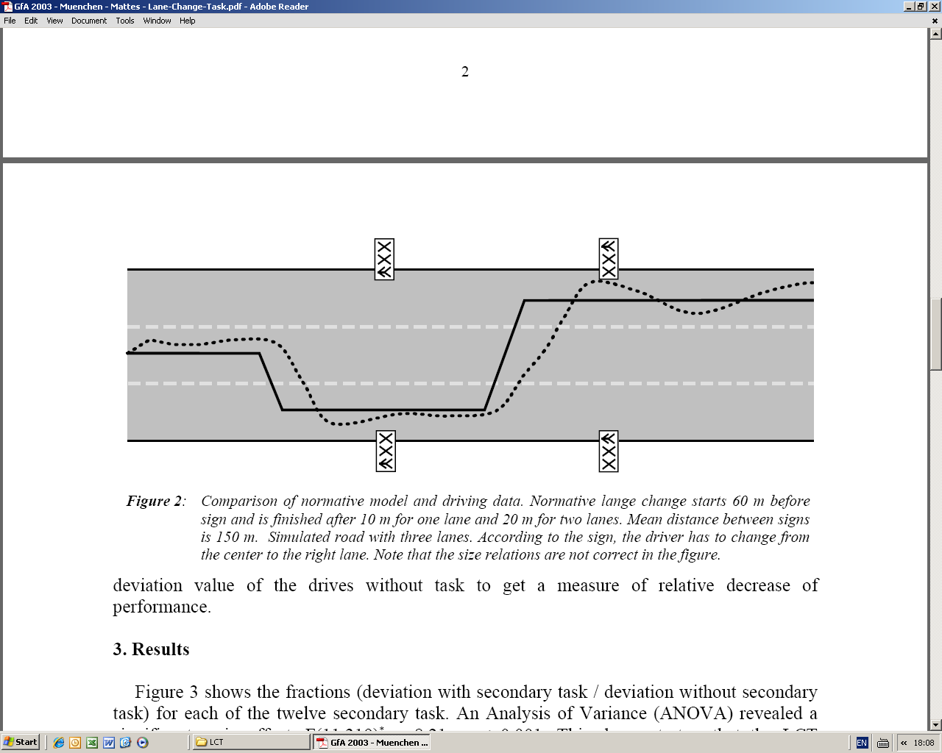
Figure 1: Schematic overview of Lane Change Task. Car approaches from the left. Solid line represents normative model for switching and driving behavior, dotted line represents actual behavior.

The average TSA-score obtained (0.72) indicates that the difference between a person’s average reaction time for the incompatible trials and that for the compatible trials is about 72 % the size of the standard deviation of all reaction times for that person.
Finally, the average CVS-score (79 % correct) indicates a rather high accuracy in answering questions requiring complex visual search.

Distracting effects of secondary tasks (Hyp. 1)
In Table 2 it can be seen that the average LCT-deviation score is about 20 cm higher for the easy secondary task (V1, 1.74 m) than for the baseline conditions C1 and C2 (average score 1.54 m). In addition, it is about 30 cm higher (1.85 m) for the complex secondary task (V2). GLM repeated measures analysis, using type of secondary task as independent variable, shows the effect of secondary task level to be statistically significant, F(2,38) = 13.99, p < 0.001 (C1 and C1 collapsed into one level). Post-hoc comparisons reveal that all levels are significantly different from each other, p < 0.05, except the difference between V1 and V2, p = 0.10. These results did not depend on the specific value of UFOV, TSA, Driving Exposure, Age, and CVS (non-significant interactions between type of secondary task and covariate scores).
We conclude that Hypothesis 1 is partly confirmed in that there is an overall distracting effect of performing a secondary visual task on the primary driving task. However, it is not confirmed in that the complex secondary task was not significantly more distracting than the easy secondary task.

Predictive value of test scores (Hyp. 2-4)
For exploratory purposes, a first multiple regression analysis was conducted with LCT/CON (average of LCT/C1 and LCT/C2) as dependent variable. The results are presented in Table 3. The regression of LCT/CON on the three test scores (UFOV, TSA, CVS) is significant, F(3,16) = 3.61, p < 0.05, and has an R² value of 0.40. In other words, 40 % of the variance in LCT/CON scores can be explained by the three test scores.

Table 2: Descriptive statistics for LCT-deviation scores, psychological test scores, and demographic variables.
Variable | Mean | Standard deviation | Variable | Mean | Standard deviation
LCT/C1 | 1.51 | 0.30 | TSA (D₁) | 0.72 | 0.24
LCT/C2 | 1.57 | 0.27 | CVS (% correct) | 78.94 | 11.54
LCT/V1 | 1.74 | 0.39 | Driver age (in years) | 32.80 | 13.10
LCT/V2 | 1.85 | 0.23 | Driving experience (cumulative license duration in months) | 102.95 | 120.45
UFOV | 159.94 | 84.53 | Driving exposure (average number of rides per week) | 2.15 | 0.93
Note: Driving Exposure coded as 1 (for 0 or 1 rides per week), as 2 (for 2 rides per week), or as 3 (for 3 or more rides per week). All numbers based on 20 observations (subjects). LCT-scores expressed as the average deviation in meters. UFOV and TSA represent error scores (the higher the score, the worse the performance).

Table 3: Outcomes of regression analysis for LCT/CON. TSA-scores multiplied by 100 before entering the analysis.
Predictor/  Component | Unstand.  coefficient | Stand.  coefficient | SS | df | MS | R² | F | t | p
Regression |  |  | 0.50 | 3 | 0.17 | 0.40 | 3.61 |  | 0.037
Error |  |  | 0.74 | 16 | 0.05
Intercept | 0.660 |  |  |  |  |  |  | 1.34 | 0.200
CVS | 0.003 | 0.13 |  |  |  |  |  | 0.59 | 0.560
UFOV | 0.002 | 0.62 |  |  |  |  |  | 2.79 | 0.013
TSA | 0.005 | 0.47 |  |  |  |  |  | 2.32 | 0.034

Table 4: Outcomes of regression analysis for LCT/(V2-CON). TSA-scores multiplied by 100 before entering the analysis.
Predictor/  Component | Unstand.  coefficient | Stand.  coefficient | SS | df | MS | R² | F | t | p
Regression |  |  | 0.26 | 3 | 0.086 | 0.24 | 1.67 |  | 0.214
Error |  |  | 0.83 | 16 | 0.052
Intercept | 1.270 |  |  |  |  |  |  | 2.44 | 0.027
CVS | -0.007 | -0.33 |  |  |  |  |  | -1.37 | 0.190
UFOV | -0.002 | -0.54 |  |  |  |  |  | -2.14 | 0.048
TSA | -0.002 | -0.24 |  |  |  |  |  | -1.06 | 0.307

Of the test scores, UFOV and TSA have significant regression coefficients, t(16) = 2.79 for UFOV and t(16) = 2.32 for TSA, both p’s < 0.05, respectively: the better the test performance, the better the LCT-performance (standardized coefficients equal 0.62 for UFOV and 0.47 for TSA).
Table 4 shows the regression analysis results for LCT/(V2-CON) (difference between LCT/V2 and LCT/CON). The regression of this variable on the three test scores (Table 3) is not significant and has an R² value of only 0.24. The regression coefficients of the test scores are only significant for UFOV, t(16) = -2.14, p < 0.05, standardized coefficient equals -0.54. However, contrary to expectation, the regression coefficient for UFOV turns out to be negative, rather than positive: the higher the UFOV-performance, the larger the amount of distraction caused by V2!
The regression analysis for LCT/(V1-CON) (difference between LCT/V1 and LCT/CON, not shown in tables) was not significant either and did not have significant regression coefficients.
In summary, neither of Hypotheses 2, 3, and 4 was confirmed. However, the LCT-baseline deviation score was significantly predicted by UFOV and TSA in the expected direction. In addition, the LCT-deviation score for the complex secondary task was significantly predicted by UFOV, but in a direction opposite from expectation.

CONCLUSIONS AND DISCUSSION
The conclusions of the experiment reported in this article can be summarized as follows.
First, both visual secondary tasks were distracting in an overall sense: the LCT-deviation scores observed under dual-task conditions were significantly higher than the ones observed under single-task conditions (LCT-baseline performance). Though the complex visual task (V2) was more distracting than the simple one (V1), the difference between the two dual-task conditions was only marginally significant.
Second, both UFOV- and TSA-performance predict LCT-baseline performance quite well. Though these predictions were not hypothesized, they indicate that under normal driving conditions (no secondary task), cognitive processes related to divided (visual) attention and task-switching ability are necessary to complete the driving task successfully. Moving the steering wheel, paying attention to the lane one is trying to keep, and paying attention to the switch-sign are complex tasks demanding a wide variety of cognitive functions, even though attention is paid to only one monitor.
Third, the effect of UFOV just mentioned may also reflect an effect of age: UFOV-performance declined with age, as did LCT-baseline performance. More research is needed to identify the precise role played by age in explaining LCT-baseline performance.
Fourth, contrary to expectations, better UFOV-performance predicted a larger amount of distraction caused by the complex secondary task (V2) (negative regression coefficient in Table 4). This was true, even after the result had been corrected for effects of age, driving experience and driving exposure. This finding is both puzzling and fascinating. One explanation is that UFOV-performance is not related at all to LCT-performance under dual-task conditions. Indeed, post-hoc data analysis revealed a very low correlation between UFOV-performance and LCT-performance when the LCT is timeshared with V2.
This low correlation may be caused by the larger visual field used under dual-task conditions: subjects now have to move their head and eyes to switch their attention between two monitors. Perhaps different types of attentional processes are needed under these circumstances, not measured by UFOV. This might be an issue to be investigated by future research. Given this finding and the finding of a positive correlation between UFOV-performance and LCT/CON (see Table 3), the negative correlation mentioned above makes perfect sense from a mathematical point of view, for the amount of distraction caused by V2 is calculated by subtracting LCT/CON from LCT/V2, resulting in larger amounts of distraction for persons having a higher UFOV-performance.
Fifth, neither TSA nor CVS were found to be predictive of the amount of distraction caused by either V1 or V2. Neither did UFOV predict the amount of distraction caused by V1. Apparently, V1 was too simple a secondary task to cause the type of distraction that can be predicted easily by psychological tests such as the ones used in our study.
Sixth, a significant negative correlation was also observed between age and CVS-performance: the older the person, the lower CVS-performance, again indicating age-related decrement. However, age did not seem to have an impact on the amount of distraction caused by V1 or V2. The precise role played by age in predicting attention-related abilities and in predicting the amount of driver distraction caused by secondary tasks remains an issue for future research.
Finally, in this study Complex Visual Search performance was not measured independently of the LCT, but, for practical reasons, was measured using the complex visual secondary task, which was performed simultaneously with an LCT-track. Because our subjects may have had different timesharing strategies, they also may have paid different amounts of attention to the CVS-task. Therefore, it is hard to know how useful the CVS-task has been in this study as a measure of controlled processing on which subjects show reliable individual differences. Future research should take up this issue and try to replicate this (or a similar) experiment using a more reliable and more valid measure of CVS.

REFERENCES
- Young, K., Regan, M., & Hammer, M. (2003). Driver Distraction: A Review of the Literature. Monash University Accident Research Centre.
- Pettitt, M., Burnett, G., & Stevens, A. (2005). Defining driver distraction. Paper presented at World Congress on Intelligent Transport Systems, San Francisco, November.
- AAA Foundation for Traffic Safety (2006).Traffic safety issues of the future: a long range research agenda. January, 2006. Washington, DC: AAA Foundation for Traffic Safety.
- Ball, K. & Owsley, C. (1993). The useful field of view test: A new technique for evaluating age-related declines in visual function. Journal of the American Optometric Association, 64, 71-79.
- Back, M.D., Schmukle, S.C., & Egloff, B. (2005). Measuring Task-Switching Ability in the Implicit Association Test. Experimental Psychology, 52(3), 167-179.
- Duncan, J., Emslie, H., Williams, P., Johnson, R., & Freer, C. (1996). Intelligence and the frontal lobe: the organization of goal-directed behavior. Cognitive Psychology, 30(3), 257-303.
- Ackerman, P.L. (1988). Determinants of individual differences during skill acquisition: Cognitive abilities and information processing. Journal of Experimental Psychology: General, 117, 288-318.
- Ball, K., Roenker, D., & Bruni, J. (1990). Developmental changes in attention and visual search throughout adulthood. In Enns, J. (Ed.), The Development of Attention: Research and Theory. North Holland: Elsevier Science Publishers, 489-508.
- Mattes, S. (2003). The lane change task as a tool for driver distraction evaluation. In H. Strasser, H. Rausch, & H. Bubb (eds.), Quality of work and products in enterprises of the future. Stuttgart: Ergonomia Verlag

